Assignment 06: Assignment and practice of Prompt Engineering to craft effective prompts.

**Task 1: Prompt Categorization**

1. **Prompt:** *"Generate a logo for a tech startup using neon colors."*
   * **Type:** Visual Prompt
   * **Reasoning:** It specifies image generation (a logo) with clear visual constraints (tech theme, neon colors).
2. **Prompt:** *"Explain blockchain to a 5-year-old."*
   * **Type:** Instructional Prompt
   * **Reasoning:** It asks for a simplified explanation suitable for a child, making it an instructional task.
3. **Prompt:** *"You are a UX designer. Suggest improvements to this app layout."*
   * **Type:** Role-based / Instructional Prompt
   * **Reasoning:** The role of UX designer is assigned, and the task requires structured suggestions.

**Task 2: Refinement Practice**

1. **Original Prompt:** *"Write a story."*
   * **Refined Prompt:** *"Write a 500-word short story for teenagers about a time-traveling student who visits ancient Egypt. Include suspense, dialogue, and a twist ending."*
2. **Original Prompt:** *"Explain AI."*
   * **Refined Prompt:** *"Explain Artificial Intelligence in 200 words for high school students. Use simple examples like Siri, chatbots, and self-driving cars."*
3. **Original Prompt:** *"Design a presentation."*
   * **Refined Prompt:** *"Create a 6-slide PowerPoint presentation for college students on 'Cybersecurity Threats in 2025.' Include slides on*
   * *Introduction*
   * *Types of Threats*
   * *Real-world Cases*
   * *Prevention*
   * *Future Trends*
   * *Conclusion.*

**Task 3: Prompt Design Exercise**

# Five Original Prompts (different domains): For ChatGPT (text-based):

"Act as a travel planner. Suggest a 5-day trip itinerary for a student budget traveler visiting Goa. Include affordable hotels, beaches, cultural spots, and food options."

# For DALL·E (image-based):

"Generate a digital poster of a futuristic classroom where students are learning with holograms and AI robots, in a colorful cyberpunk style."

# For SORA (video-based):

"Create a 12-second video of a dragon flying over a modern city skyline at night, breathing fire into the sky with cinematic lighting."

# For Coding/Logic:

"Write a Python program that generates the Fibonacci sequence up to 20 terms and highlights the even numbers in the output."

# For Education/Training:

"You are a physics teacher. Create a 10-question

multiple-choice quiz for Class 11 students on Newton’s Laws of Motion, with answer key included."

# DALL·E (image-based)

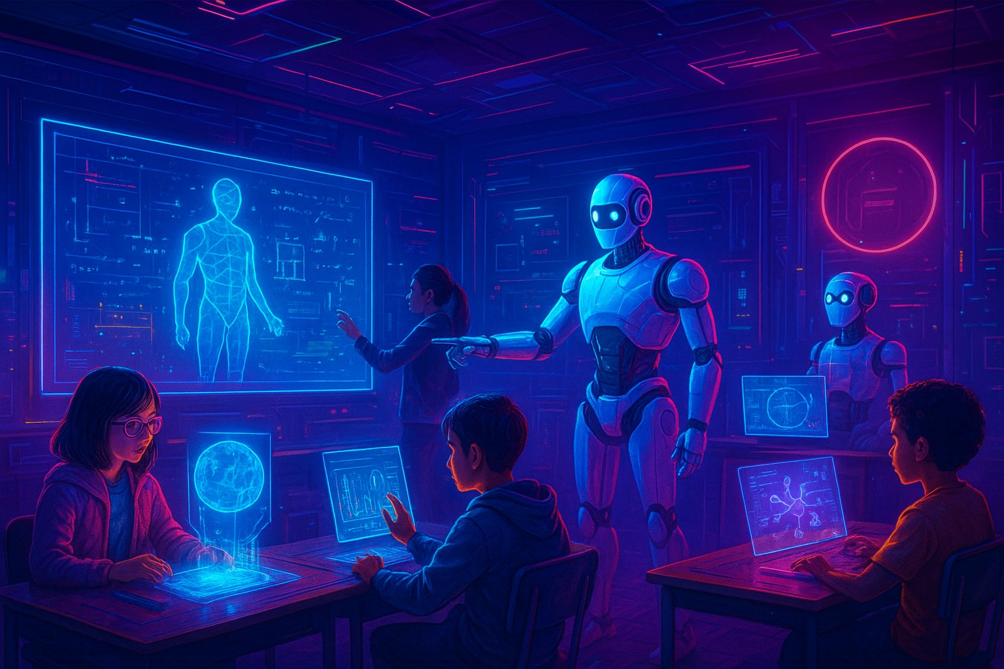

**Coding/Logic:**

# Generate and display the first 20 Fibonacci numbers, highlighting even ones.

def fibonacci(n=20): a, b = 0, 1

seq = []

for _ in range(n): seq.append(a) a, b = b, a + b return seq

def highlight(num):

# Bold white text on blue background for evens if num % 2 == 0:

return f"\033[1;97;44m{num}\033[0m" return str(num)

def mark_plain(num):

return f"[{num}]" if num % 2 == 0 else str(num) if name == " main ":

seq = fibonacci(20)

# Colored line (if your terminal supports ANSI colors) colored_line = ", ".join(highlight(n) for n in seq) print("Fibonacci (even numbers highlighted):") print(colored_line)

# Plain-text fallback (no colors)

plain_line = ", ".join(mark_plain(n) for n in seq) print("\nPlain text (even numbers in brackets):") print(plain_line)